Sections completed

In my assignment, I have completed the following sections:

* Access to the data using simple http web service calls (10 marks)
* Options to return the data in text, json (the default) or xml (10 marks)
* Google App Engine or Microsoft Azure to implement the application on a remote cloud based server. (20 marks)
* A WSDL description of the interface to the web service (5 marks)
* Access to the data using REST type interaction (10 marks)
* An Ajax based web front end to retrieve the data and display in a suitable format using library based routines for an enhanced user interface (15 marks)

Accessing my Azure project

Access to the project can be found on the following link:

https://webapp-180111201317.azurewebsites.net/

Ajax HTTP call example

Calling /getFilmById?id=10121 :

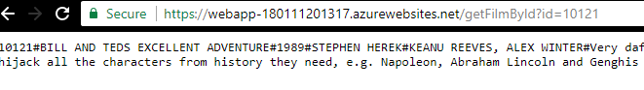

Calling /getFilmsByName?name=187:

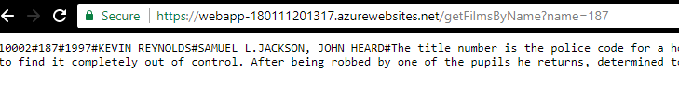

Calling /getFilmById?id=10121&format=xml :

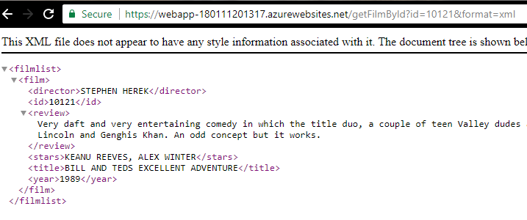

Calling /getFilmById?id=10121&format=json :

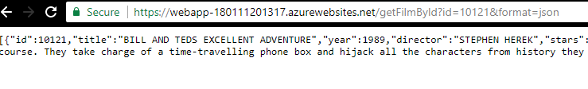

SOAP Project - Using the interface

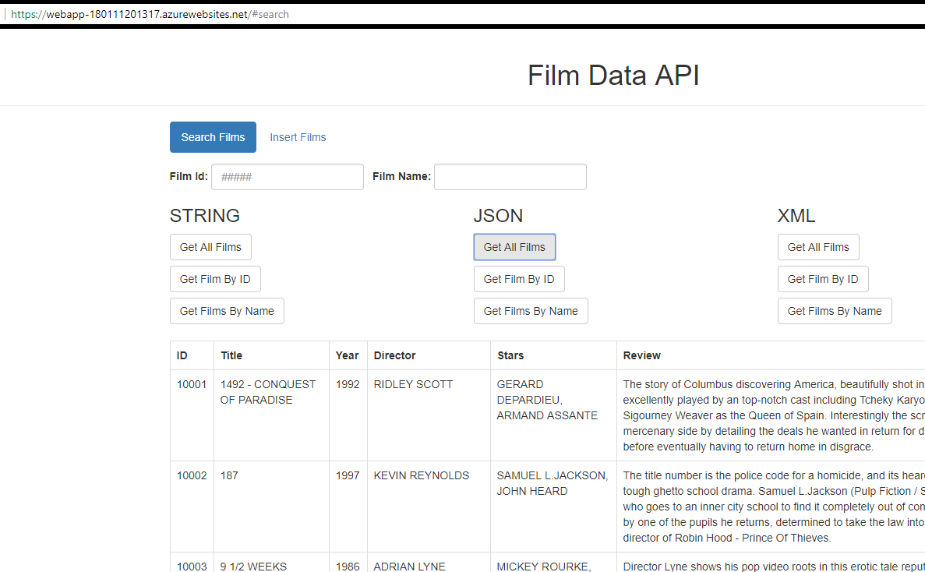

I won’t do many screenshots of this, feel free to go to the link provided.

Cloud database

For my database, I used amazon web services. Within my FilmDAO.java there are three lines to connect to a database. I comment the relevant ones out before deploying to azure so that it uses my AWS mysql server. I’m able to modify the database settings (speed of machines, amount of connections) from the AWS web client.

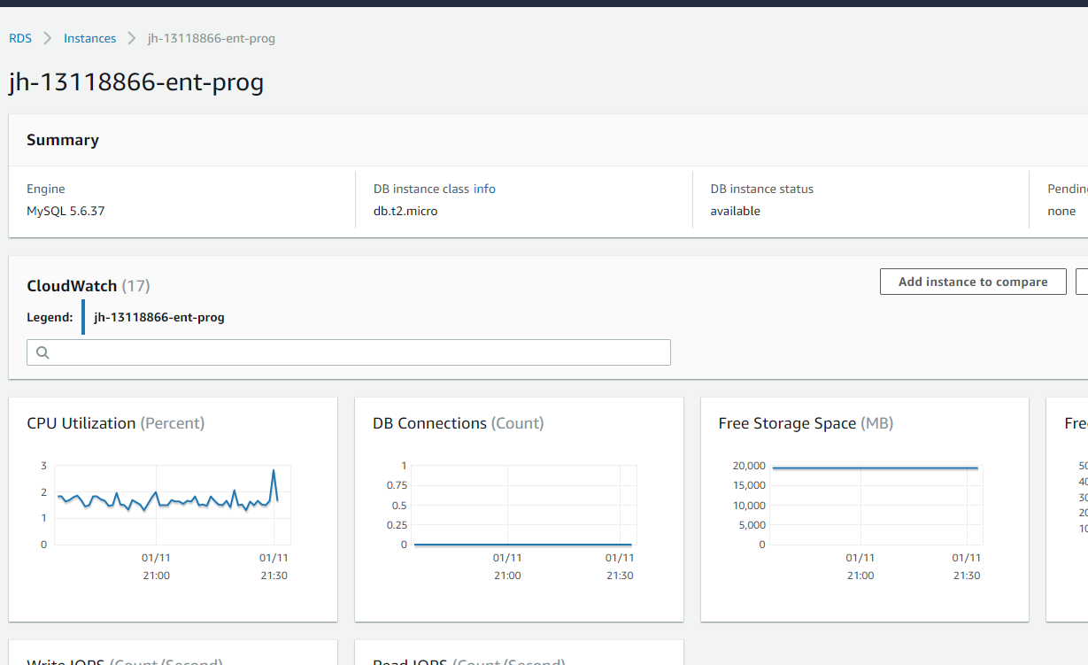

RESTful implementation

All films can be found by the following URL: <http://localhost:8080/com.democo.jersey.film/rest/films>

This returns JSON or XML of all the films.

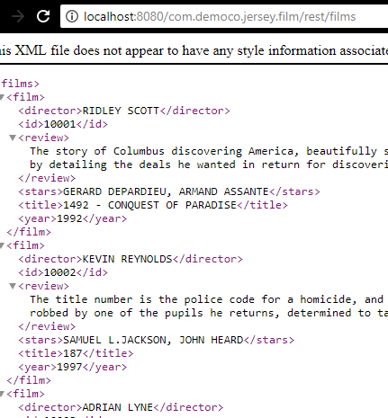

Film by ID can be found by the following URL:

[http://localhost:8080/com.democo.jersey.film/rest/films/id/{id}](http://localhost:8080/com.democo.jersey.film/rest/films/id/%7bid%7d)

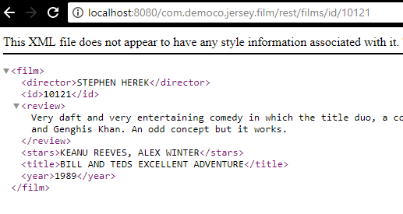

Films by name can be found with the following URL:

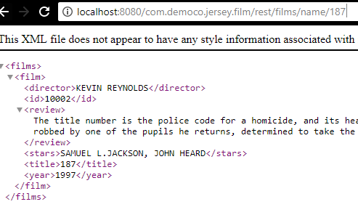

A client can be used to specify which datatype is returned, my browser just favours XML.

Insert film can be accessed from <http://localhost:8080/com.democo.jersey.film/>

Or via a client app which builds a form and uses the newFilm method.

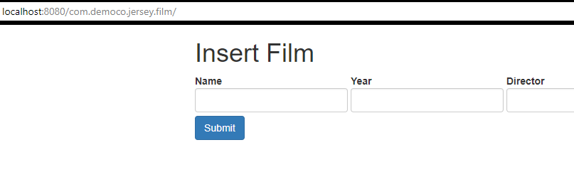

Redirects to this page on successful insert.

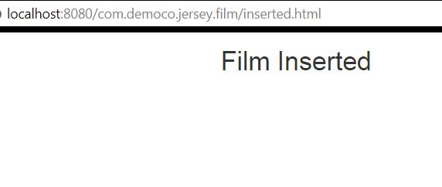

A sample of FilmResource is shown below.

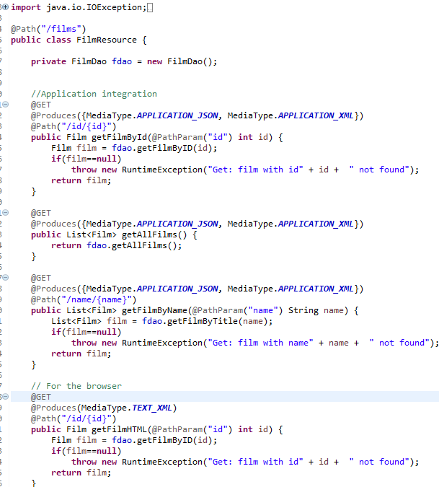

A WSDL was generated for this can be found in the following file:

com.democo.jersey.film\WebContent\wsdl\FilmResource.wsdl